SET-3
Dataset
Employee ID | Department | Years of Service | Performance Score
1 | Sales | 5 | 85
2 | HR | 3 | 92
3 | Marketing | 7 | 78
4 | Sales | 4 | 90
5 | HR | 2 | 76

Task 1: Create a Line Chart (Performance Trend)
Steps in Tableau
- Open Tableau Public/Desktop.
- Connect to the Employee dataset (Excel/CSV).
- Drag Years of Service → Columns.
- Drag Performance Score → Rows.
- In the Marks card, select Line.
- Drag Department → Color (to show a legend).
- Drag Employee ID → Label.

Employee Performance Trend Over Years of Service
Axis Labels
- X-axis: Years of Service
- Y-axis: Performance Score

Task 2: Bar Chart (Employees by Department)
Steps
- Create a new worksheet.
- Drag Department → Columns.
- Drag Employee ID → Rows.
- Change aggregation to COUNT.
- Select Bar from Marks.
- Turn on Show Mark Labels.
Chart Title
Number of Employees by Department
Axis Labels
- X-axis: Department
- Y-axis: Number of Employees

Task 3: Scatter Plot (Years of Service vs Performance)
Steps
- Create a new worksheet.
- Drag Years of Service → Columns.
- Drag Performance Score → Rows.
- Select Scatter Plot from Show Me.
- Drag Department → Color.
- Drag Employee ID → Label.
Chart Title
Years of Service vs Performance Score
Axis Labels
- X-axis: Years of Service
- Y-axis: Performance Score

Insights
- Employees with more years of service do not always have higher performance scores.
- Employee with 3 years of service achieved the highest score (92).
- Employee with 7 years of service scored 78, showing experience alone does not determine performance.
- There is no strong positive correlation between years of service and performance in this small dataset.

Task 4: Tableau Dashboard
Steps
- Click New Dashboard.
- Set dashboard size to Automatic.
- Drag the following worksheets onto the dashboard:
  - Employee Performance Trend (Line Chart)
  - Employees by Department (Bar Chart)
- Arrange them side by side or one above the other.
- Enable interactive filtering:
  - Click the dropdown on a chart.
  - Select Use as Filter.
Dashboard Title
Employee Performance Evaluation Dashboard
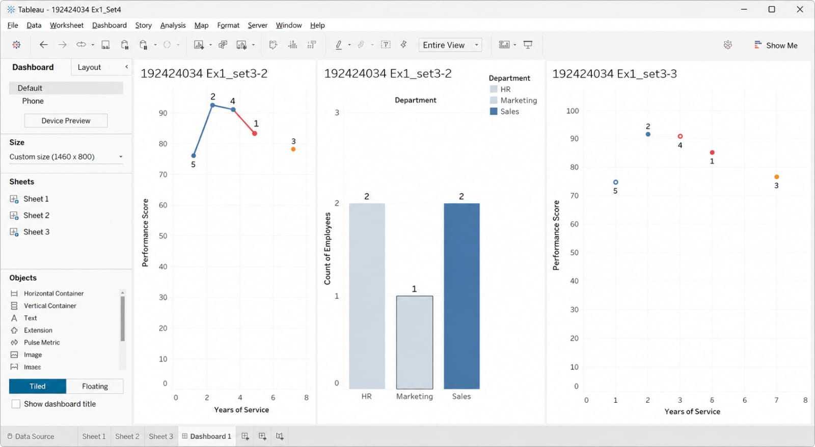

Dashboard Features
- Displays performance trends over years of service.
- Shows employee distribution across departments.
- Interactive filtering between charts.
- Easy comparison of departments and employee performance.

